Geometry: Unit 12, Lesson 1
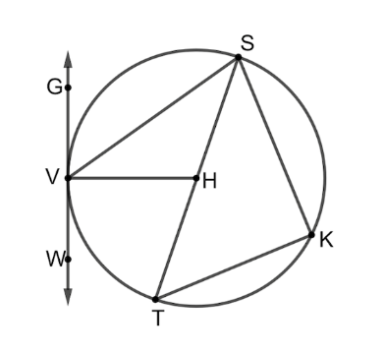
- Circle $H$ is shown with point $V,S,K,$and $T$ on the circle and points $G$ and $W$ outside the circle. Give two angles that measure $90°$
$$∠HVG, ∠SKT$$

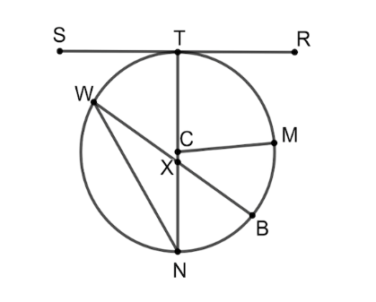

- Circle $C$ is shown with points $T,M,B,N,$ and $W$ on the circle, points $R$ and $S$ outside the circle, and point $X$ inside the circle. What Segment is the longest chord shown on circle $C$? Give a segment that is the radius of circle $C$. Give an angle that measures $90°$.
$TN, CT, ∠CTS$

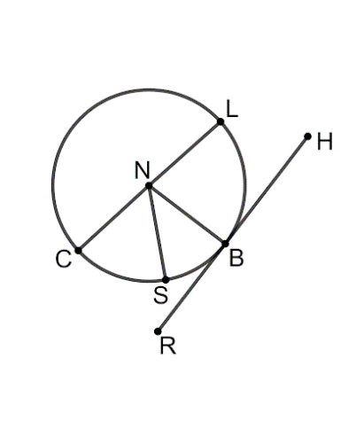

- Circle $N$ is shown with points $C,S,B,$ and $L$ on the circle and points $R$ and $H$ outside the circle. What is the tangent of the circle? Give an angle that measures $90°$.
$$\overline{RH}, ∠HBN$$

